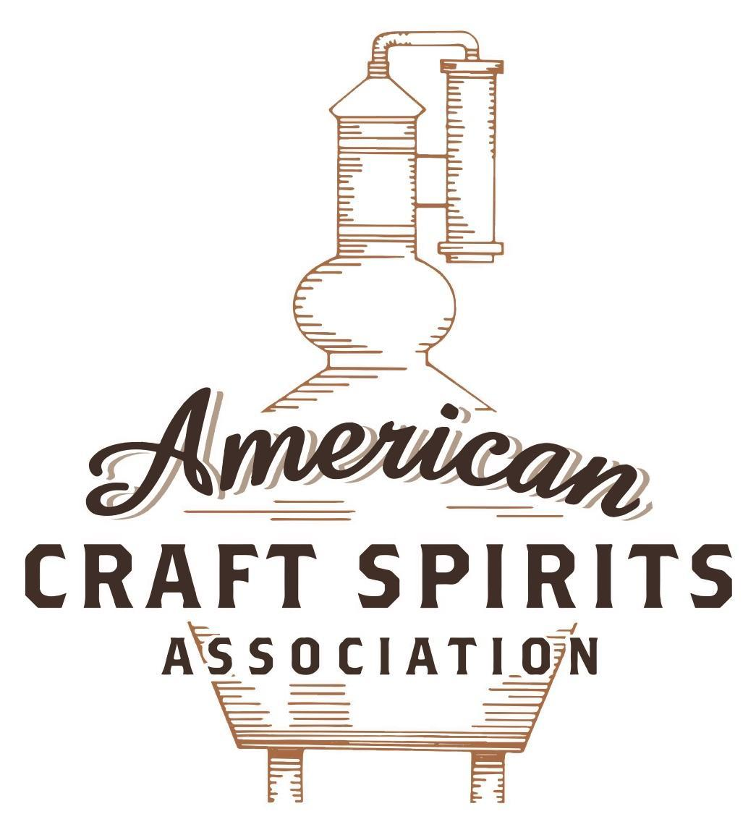
Spirits DtC Shipping Guide

This guide summarizes the direct-to-consumer shipping rules for distilleries in all 50 states and D.C. and also addresses the measures state governments have taken to ease delivery and shipping restrictions during the COVID-19 pandemic.

DtC Quick Guide Comparison

Out-of-State Distilleries  Can Ship Into State? |  |  |  | In-State Distilleries  Can Ship Within State?
State | Yes | No |  | State | Yes | No
AL |  | X |  | AL |  | X
AK | X |  |  | AK | X
AZ | X |  |  | AZ | X
AR |  | X |  | AR |  | X
CA |  | X* |  | CA |  | X*
CO |  | X |  | CO |  | X
CT |  | X* |  | CT |  | X
DE |  | X |  | DE |  | X
DC | X |  |  | DC | X
FL |  | X |  | FL |  | X
GA |  | X |  | GA |  | X
HI |  | X* |  | HI |  | ?*
ID |  | X |  | ID |  | X
IL |  | X* |  | IL |  | X*
IN |  | X |  | IN |  | X
IA |  | X* |  | IA |  | X*
KS |  | X |  | KS |  | X
KY | X |  |  | KY | X
LA |  | X |  | LA |  | X
ME |  | X* |  | ME |  | X*
MD |  | X |  | MD |  | X
MA |  | X |  | MA |  | X
MI |  | X |  | MI |  | X
MN |  | X |  | MN |  | X
MS |  | X |  | MS |  | X
MO |  | X |  | MO |  | X
MT |  | X |  | MT |  | X
NE | X |  |  | NE | X
NV |  | X* |  | NV |  | X
NH | X |  |  | NH |  | X*
NJ |  | X* |  | NJ |  | X*
NM |  | X |  | NM |  | X
NY |  | X* |  | NY |  | X*
NC |  | X |  | NC |  | X
ND | X |  |  | ND | X
OH |  | X |  | OH |  | X
OK |  | X |  | OK |  | X
OR |  | X |  | OR | X
PA |  | X* |  | PA |  | X
RI |  | X* |  | RI |  | X
SC |  | X |  | SC |  | X
SD |  | X |  | SD |  | X
TN |  | X |  | TN |  | X
TX |  | X |  | TX |  | X
UT |  | X |  | UT |  | X
VT |  | X |  | VT |  | X
VA |  | X |  | VA |  | X
WA |  | X* |  | WA | X
WV |  | X* |  | WV |  | X*

WI |  | X |  | WI |  | X
WY |  | X |  | WY |  | X

Notes:
*CA: If passed and signed into law, Senate Bill 620 would allow licensed distilled spirits producers in states other than California and licensed distilled spirits manufacturers or craft distillers in California who obtain distilled spirits direct shipper permits to ship directly to consumers in California
*CT: Consumers with appropriate permit may receive alcohol shipments
*HI: Consumers with appropriate permit may receive alcohol shipments; If passed and signed into law, Senate Bill 65 would allow licensed distilled spirits manufacturers in Hawaii and in states other than Hawaii who obtain direct shipper permits to ship directly to consumers in Hawaii
*IL: If passed and signed into law, Senate Bill 0532 would allow licensed distilled spirits producers in Illinois and in states other than Illinois who obtain distillery shippers’ licenses to ship directly to consumers in Illinois
*IA: If passed and signed into law, House File 639 would allow native distilled spirits manufacturers in Iowa and in states other than Iowa who obtain direct shipper permits to ship directly to consumers in Iowa and to consumers in states other than Iowa
*ME: If passed and signed into law, Legislative Document 1358 would allow distilleries outside of Maine with current manufacturer licenses and distilleries licensed in Maine who obtain spirits direct shipper licenses to ship directly to consumers in Maine
*NJ: (1) If passed and signed into law, Assembly Bill 3167 would allow a craft distillery licensees to ship no more than 9 liters of distilled spirits to a consumer in New Jersey; (2) If passed and signed into law, Senate Bill 3020 would allow craft distillery licensees in New Jersey or in states other than New Jersey to ship no more than 20 liters of distilled spirits to a consumer in New Jersey via common carrier
*NV: Licensed individuals can import one gallon per month of spirits for personal use and the out-of-state supplier must pay excise tax
*NH: If passed and signed into law, Senate Bill 125 would allow licensed liquor manufacturers who obtain direct to consumer shipping permits from the commission to ship directly to consumers in New Hampshire
*NY: Consumer may import up to 90L of liquor per year for personal use without a license; If passed and signed into law, Assembly Bill 3275 would allow licensed liquor manufacturers in states other than New York and licensed distillers and farm distillers in New York to ship no more than thirty-six cases (no more than nine liters per case) of liquor to consumers in New York
*PA: Consumer may place a special liquor order and distiller must ship to a PLCB-operated store
*RI: Distiller can only ship to customer if order was personally placed by customer at distiller's premises
*WA: If passed and signed into law, House Bill 1432 would allow licensed spirits manufacturers in states other than Washington to ship spirits to consumers in Washington
*WV: Distilleries, mini-distilleries, or micro-distilleries licensed in West Virginia or a state other than West Virginia who obtain private direct shipper licenses to ship to a consumer in West Virginia, however the shipments must be made to a retail liquor outlet

MISSOURI
Shipment Outbound – Silent.
Shipment Inbound – No, direct shipments are only allowed for wine manufacturers.

Shipment Intra-state – No, a distillery must sell liquors through a licensed MO wholesaler or on its premises to consumers with the appropriate license (RSMo. § 311.180(3); § 311.070(1)).
COVID-19 Measures – During the state of emergency, the ATC is temporarily allowing retailer-packaged alcohol beverages under certain conditions:
The alcohol container must be durable, leakproof, and sealable, and must meet the minimum size requirements outlined in the Code of State Regulations [11 CSR 70-2.010(5)];
The customer must have ordered and purchased a meal simultaneous with the liquor purchase;
The licensee must provide the customer with a dated receipt for the alcohol beverage(s); and
The sealed alcohol container must either be:
Placed in a one-time-use, tamperproof, transparent bag which must be securely sealed, or;
The container opening must be sealed with tamperproof tape.
The governor has extended the state of emergency until August 31, 2021.
Emergency Waiver - Retailer-Packaged Alcohol Link:
https://atc.dps.mo.gov/IndustryCircular/circular-retailer-packaged-alcohol-3-29-2021.pdf
Executive Order 21-07 Link: https://www.sos.mo.gov/library/reference/orders/2021/eo7
Citation (shipment)
Missouri Revisor of Statutes
311.180. Manufacturers, wholesalers, solicitors — license fees — wholesalers, sale to gaming commission licensees, allowed. — 1. No person, partnership, association of persons or corporation shall manufacture, distill, blend, sell or offer for sale intoxicating liquor within this state at wholesale or retail, or solicit orders for the sale of intoxicating liquor within this state without procuring a license from the supervisor of alcohol and tobacco control authorizing them so to do. For such license there shall be paid to and collected by the director of revenue annual charges as follows:
(3) For the privilege of manufacturing, distilling or blending intoxicating liquor of all kinds within this state and the privilege of selling to duly licensed wholesalers and soliciting orders for the sale of intoxicating liquor of all kinds, to, by or through a duly licensed wholesaler within this state, the sum of four hundred and fifty dollars;
2. Solicitors, manufacturers and blenders of intoxicating liquor shall not be required to take out a merchant's license for the sale of their products at the place of manufacture or in quantities of not less than one gallon.
Link: https://revisor.mo.gov/main/OneSection.aspx?section=311.180&bid=16589
311.070. Financial interest in retail businesses by certain licensees prohibited, exceptions — penalties — definitions — activities permitted between wholesalers and licensees — certain contracts unenforceable — installation of nonrefrigeration dispensing accessories — contributions to certain organizations permitted, when — sale of Missouri wines only, license issued, when. — 1. Distillers, wholesalers, winemakers, brewers or their employees, officers or agents shall not, except as provided in this section, directly or indirectly, have any financial interest in the retail business for sale of intoxicating liquors, and shall not, except as provided in this section, directly or indirectly, loan, give away or furnish equipment, money, credit or property of any kind, except ordinary commercial credit for liquors sold to such retailer dealers. However, notwithstanding any other provision of this chapter to the contrary, for the purpose of the promotion of tourism, a distiller whose manufacturing establishment is located within this state may apply for and the supervisor of alcohol and tobacco control may issue a license to sell intoxicating liquor, as in this chapter defined, by the drink at retail for consumption on the premises where sold; and provided further that the premises so licensed shall be in close proximity to the distillery and may remain open between the hours of 6:00 a.m. and 1:30 a.m., Monday through Saturday and between the hours of 6:00 a.m. on Sundays and 1:30 a.m. on Mondays. The authority for the collection of fees by cities and counties as provided in section 311.220, and all other laws and regulations relating to the sale of liquor by the drink for consumption on the premises where sold, shall apply to the holder of a license issued under the provisions of this section in the same manner as they apply to establishments licensed under the provisions of section 311.085, 311.090, or 311.095.
Link: https://revisor.mo.gov/main/OneSection.aspx?section=311.070&bid=49620&hl=

The American Craft Spirits Association (ACSA) is working diligently to give our members and industry partners relevant, current updates on statutes and regulations impacting production, sale and distribution of spirits. With the declaration of the novel coronavirus (COVID-19) in early 2020, many states have issued temporary policy changes or longer-term modernization of alcohol beverage laws. State statutes, regulations created by the state alcohol regulatory authority, as well as any other relevant guidance provided by such authorities (such as advisories, opinions, bulletins, etc.) were reviewed in creation of this document. No city or county ordinances were reviewed. Distillers should be aware that even in states where direct shipping is permissible, always remember to avoid shipping to dry counties. Please consult with your state guild or alcohol beverage authority for the most up-to-date information. This content is intended for educational and informational purposes only. ACSA's pro bono law firm of Malkin Law P.A. provided the core content found in this comprehensive overview of the spirits distribution after COVID-19. It was completed in August 2021 and will be updated regularly. If you have updates you would like to provide, please send to legislation@americancraftspirits.org or directly to the law firm at: ryan@malkin.law / malkin.law. Thank you.

